**VISVESVARAYA TECHNOLOGICAL UNIVERSITY**

**“Jnana Sangama”, Belgaum -590014, Karnataka.**



**PROJECT WORK-2 REPORT**

**On**

**“EXPENSE TRACKER”**

***Submitted by***

**BHA (USN1)**

**YOGI (USN2)**

**DHANUSH (24BECS405)**

**K L SRUJAN (24BECS419)**

***Under the Guidance of***

|  |  |
| --- | --- |
| **Dr.MRP**  **Designation** |  |

***in partial fulfillment for the award of the degree of***

**BACHELOR OF ENGINEERING**

***in***

**COMPUTER SCIENCE AND ENGINEERING**



**B.M.S. COLLEGE OF ENGINEERING**

**(Autonomous Institution under VTU)**

**BENGALURU-560019**

**Mar 2024**

**B. M. S. College of Engineering,**

**Bull Temple Road, Bangalore 560019**

(Affiliated To Visvesvaraya Technological University, Belgaum)

**Department of Computer Science and Engineering**



**CERTIFICATE**

This is to certify that the project work entitled **“EXPENSE TRACKER”** carried out by **BHAVYA(USN1), YOGI(USN2), DHANUSH(24BECS405), K L SRUJAN (24BECS419)** who are bonafide students of **B. M. S. College of Engineering.** It is in partial fulfillment for the award of **Bachelor of Engineering in Computer Science and Engineering** of the Visveswaraiah Technological University, Belgaum during the year 2024. The project report has been approved as it satisfies the academic requirements in respect of **Full Stack Web Development(23CS3AEFWD)** work prescribed for the said degree.

Signature of the Guide                 Signature of the HOD

Dr. MRP Dr. Jyothy S Nayak

Assistant Professor Prof & Head of Dept of CSE

BMSCE, Bengaluru BMSCE, Bengaluru

External Viva

Name of the Examiner                                                               Signature with date

**B.M.S. COLLEGE OF ENGINEERING**

**DEPARTMENT OF COMPUTER SCIENCE AND ENGINEERING**



**DECALARATION**

We, **BHAVYA(USN1), YOGI(USN2), DHANUSH(24BECS405), K L SRUJAN (24BECS419)** students of 3rd Semester, B.E, Department of Computer Science and Engineering, BMS College of Engineering, Bangalore, hereby declare that, this Full Stack Web Development entitled **"EXPENCE TRACKER"** has been carried out by us under the guidance of Dr. Selva kumar S, Assistant Professor, Department of CSE, BMS College of Engineering, Bangalore during the academic semester Dec 2023 - Mar 2024.

We also declare that to the best of our knowledge and belief, the development reported here is not from part of any other report by any other students.

Signature

**BHAVYA(USN1)**

**YOGI(USN2)**

**DHANUSH(24BECS405)**

**K L SRUJAN (24BECS419)**

**TABLE OF CONTENTS**

|  |  |  |
| --- | --- | --- |
| **Serial**  **No.** | **TITLE** | **PAGE NO.** |
| 1 | **Introduction** | 1 |
| 1.1 | Overview | 1 |
| 1.2 | Motivation | 1 |
| 2 | **Software Requirement Specification** | 2 |
| 2.1 | Hardware Requirements | 2 |
| 2.2 | Software Requirements | 2 |
| 3 | **ER diagram of the project** | 3 |
| 4 | **Schema of project** | 4 |
| 5 | **User Interface Design** | 5 |
| 5.1 |  | 5 |
| 5.2 |  | 6 |
| 5.3 |  | 7 |
| 5.4 |  | 9 |
| 5.5 |  | 10 |
| 5.6 |  | 10 |
| 5.7 |  | 18 |
| 5.8 |  | 18 |
| 5.9 |  | 22 |
| 5.10 |  | 22 |

**INTRODUCTION**

* 1. **Overview**

The project we are working on aims to provide users with a comprehensive tool to track and manage their financial activities. It includes features that help individuals maintain a clear overview of their income, expenses, and savings goals. The key functionalities of the project are:

* Income and Expenses Management: Users can input their income and expenditures manually, which will allow them to have an organized record of their financial inflows and outflows.
* Pictorial Representation: This feature visually represents the financial data through graphs or charts, making it easier for users to understand their spending habits, income patterns, and savings progress.
* Loan Overview: This function gives a snapshot of any outstanding loans, providing details like loan amount, repayment progress, and due dates.
* Goals: The project allows users to set specific financial goals, such as saving for a vacation, purchasing a house, or paying off a loan. The system will track progress towards these goals.
* Transaction History: Users can maintain a record of all past transactions, giving them the ability to review their financial history and spot trends or areas for improvement.

**1.2 Motivation**

The motivation behind this project is to empower individuals to take control of their finances in an easy and organized manner. Many people struggle with budgeting, tracking spending, and saving money, which can lead to financial stress and poor financial decisions. The project addresses these challenges by offering an intuitive, user-friendly platform that promotes financial literacy and accountability.

Key motivational points include:

* Financial Awareness: With manual data entry and clear visual representations, users will become more aware of their spending habits, income streams, and overall financial situation.
* Improved Financial Planning: By integrating goals and transaction history, users can make better-informed decisions about their money, prioritize important expenses, and work towards their financial objectives.
* Loan Management: Providing a loan overview ensures that users don’t miss important repayment deadlines and can manage their debts effectively, leading to better credit scores and financial stability.
* Empowerment: Ultimately, this project empowers users to actively participate in their financial journey, make adjustments as needed, and work towards building a secure financial future.

By offering a tool that is simple yet comprehensive, the project helps users turn financial management from a daunting task into a manageable and even motivating process.

**SOFTWARE REQUIREMENTS**

**2.1 Hardware Requirements:**

* A PC with the following or greater specifications:
  + Intel Core i3 or higher
  + 8 GB RAM
  + 500 GB Hard Drive
* Internet connection is not need

**2.2 Software Requirements:**

* Operating system : Windows
* Front end technologies are : HTML, CSS, JavaScript,PhP
* IDE : VS Code
* Back end requirement : PHP
* Server : XAMPP server

**3. ER DIAGRAM OF THE PROJECT**

EQUIP_NAME





SKILL

EMAIL

PASSWORDD

**EQUIPMENT_INFO**

EQUIP_NO



ADDS

EQUIP_QTY





**TRAINER_INFO**

TRAINER_ID



PASSWORDDDD



ADMIN M N

ADDS



TRAINER_NAME

USERNAME



USERNAME



TEACHESS

ADDS



ATTENDED



PASSWORD

CLASS_ID



M N 

M

FIRST

LAST

TRAINER_ID

M

AGE



**CLASSES**





**MEMBER_INFO**

GENDERR

CLASS_NAME



N

DOB

USERNAMEE

TRAINER_NAME



CONTACTT

ATTENDED

EMAIL

M



M

PAYS

CLASS_NAME



USERNAME



SLNO



FEE

DAYS

N 



FIRST

**ATTENDANCE**

MUSER



**PAYMENT**

LAST

TUSER

**4. SCHEMA OF THE PROJECT**

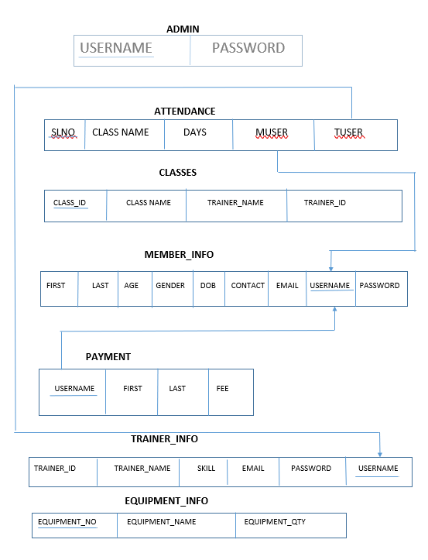

**USER INTERFACE DESIGN**

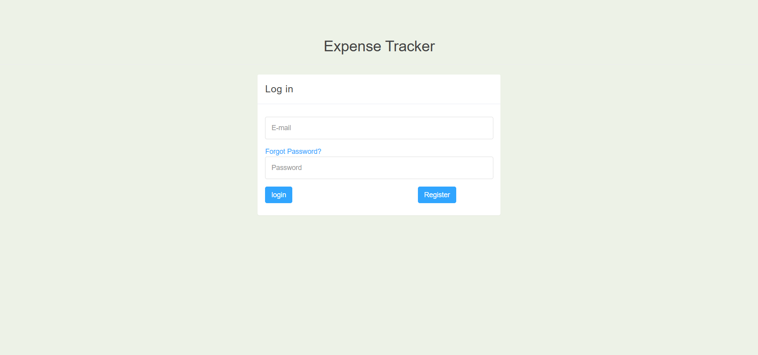

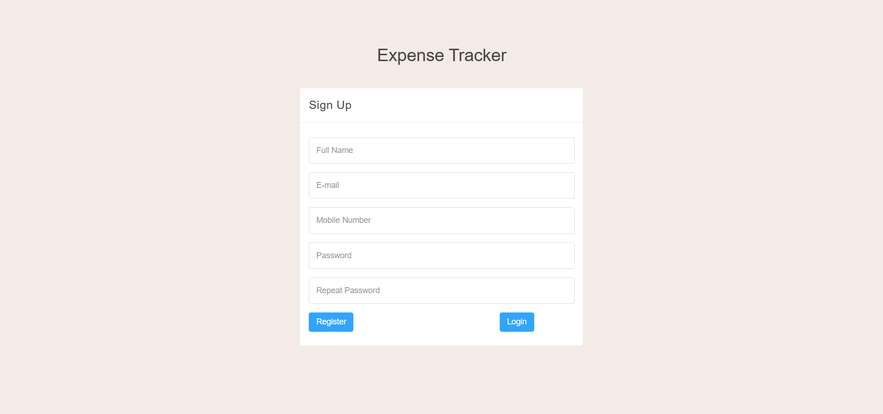

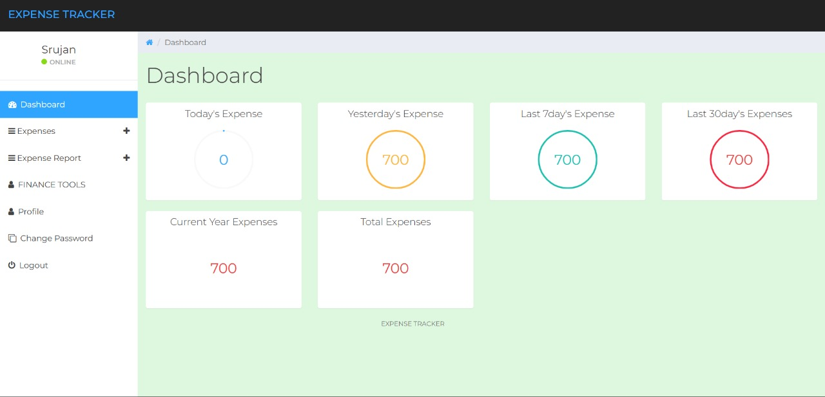

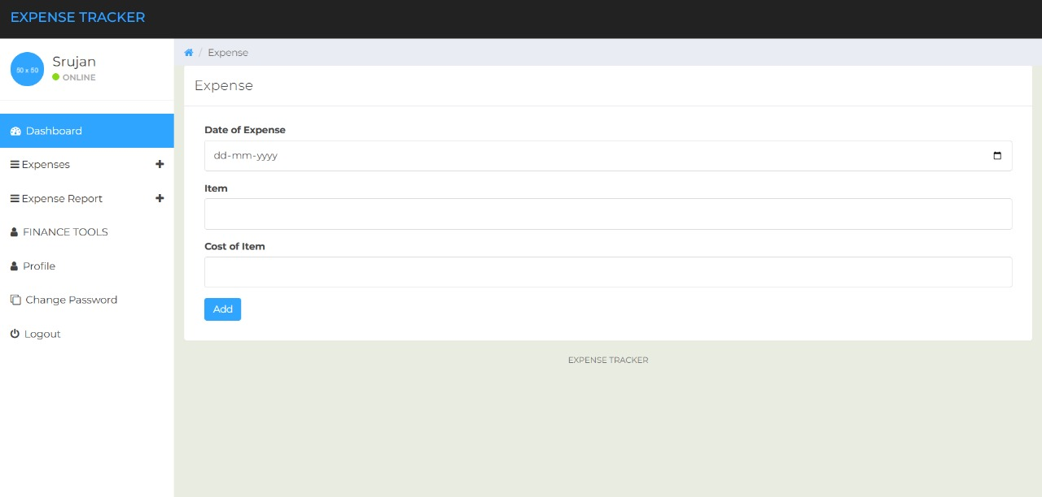

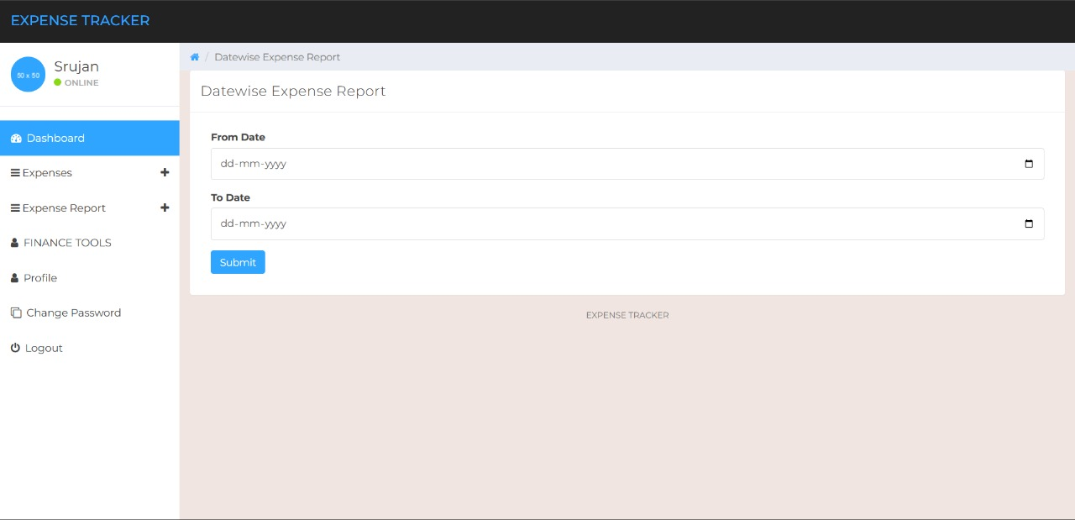

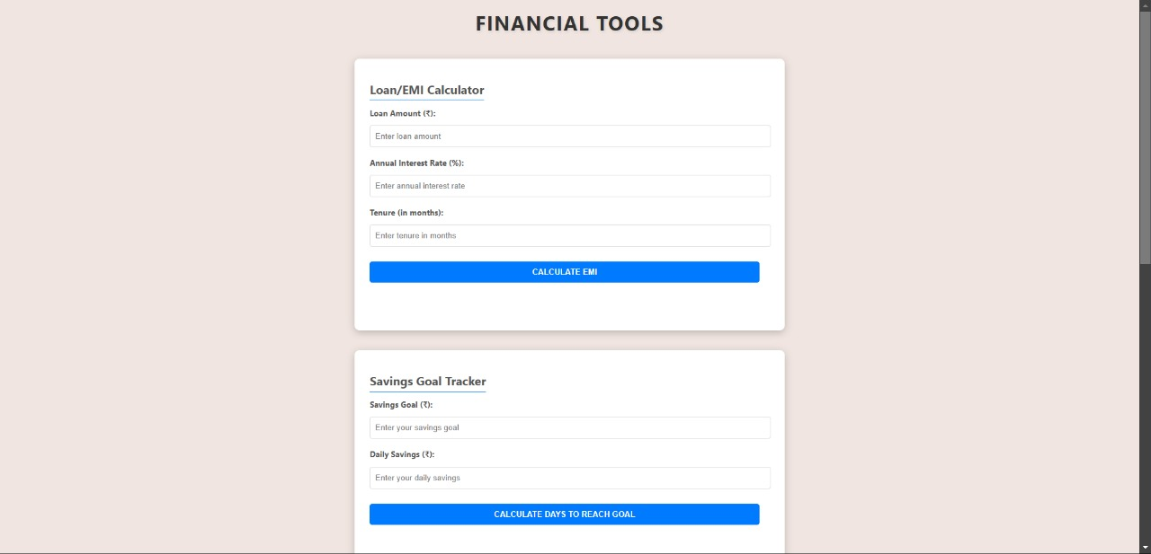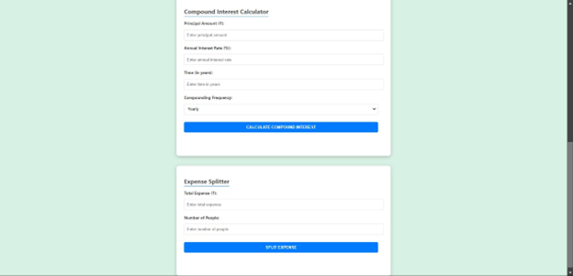

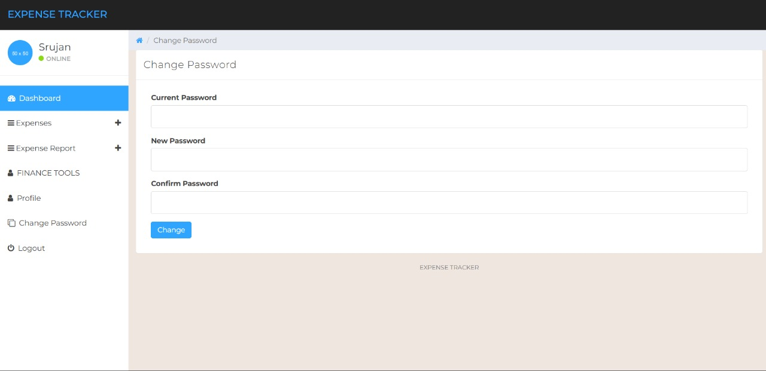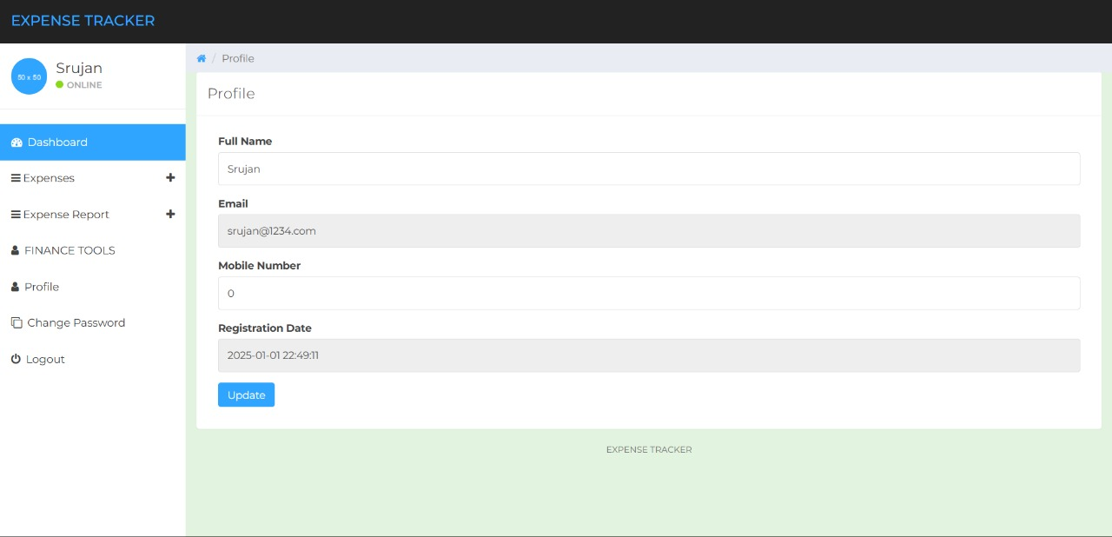

**REFERENCES:**

**Please provide all the website links you used as reference to build the project**